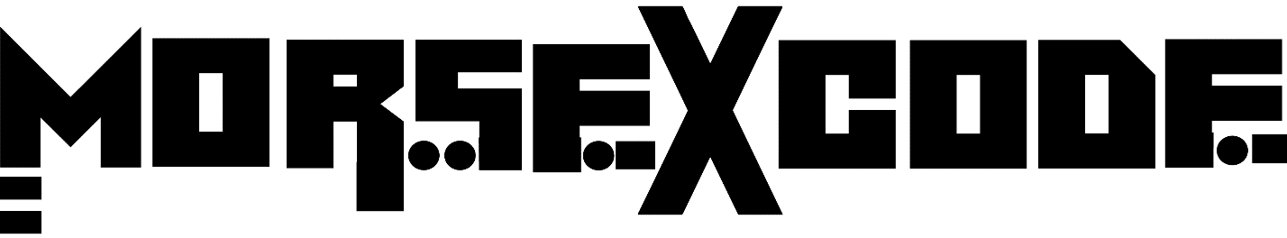
“We Speak through music”
Known for Lasers, Their Custom Mapped Masks, The hidden Morse Code messages in their music, and Most off all the Musical journey they take their fans on from the moment they take the stage, This Super Duo both as Morse X Code & their previous alias’s has rocked some of the biggest events and have had the honor of playing with some of the largest and most legendary artists in the world. From the launch of Morse X Code, and with only one official release on Beatport (under Powerhouse Records), This groups performances & sets sent shockwaves throughout Miami and throughout Florida landing them a monthly residency at Treehouse (Miami’s #1 spot for underground music), Headlining appearances at The Venue (South Florida’s largest indoor venue at the time), and at Festivals and events throughout the entire state. Then Covid hit.
All though Morse X Code did a special Live stream for their fans, these 2 decided to take a step back and take time to refine their sound in the studio as they prepare to complete and release their new EP. They emerged only ONCE to play a closing set of their unreleased music as the ONLY hard techno set for Insomniacs Forbidden Kingdom Festival at Orlando Fairgrounds. The response sealed their musical fate. All though still adding some progressive, glitchy, techy, acidy, and dirty sound into their sets, what you can expect is a musical journey of 130 bpm Hard Techno leaving their fans and crowd begging for Ids and waiting for their next performance. This ominous group is re-emerging & more refined and harder than ever. The Morse X Code experience is coming….

Short Bio –
Known for their Musical Journeys they take their fans and crowds on, Morse X Code has had the honor of playing for the most well-known event producers in the US, as well as the biggest and most renown venues and festivals in Miami & Florida. It is not the Lasers in their show, It is not masks, It is the energy packed experience through music & sound in which they send their message. Get ready to experience Morse X Code .-- . / ... .--. . .- -.- / - .... .-. --- ..- --. .... / -- ..- ... .. -.-.

